Main Street Corridor Project
Fact Sheet

Prepared by Hopkinton Select Board November 5, 2019
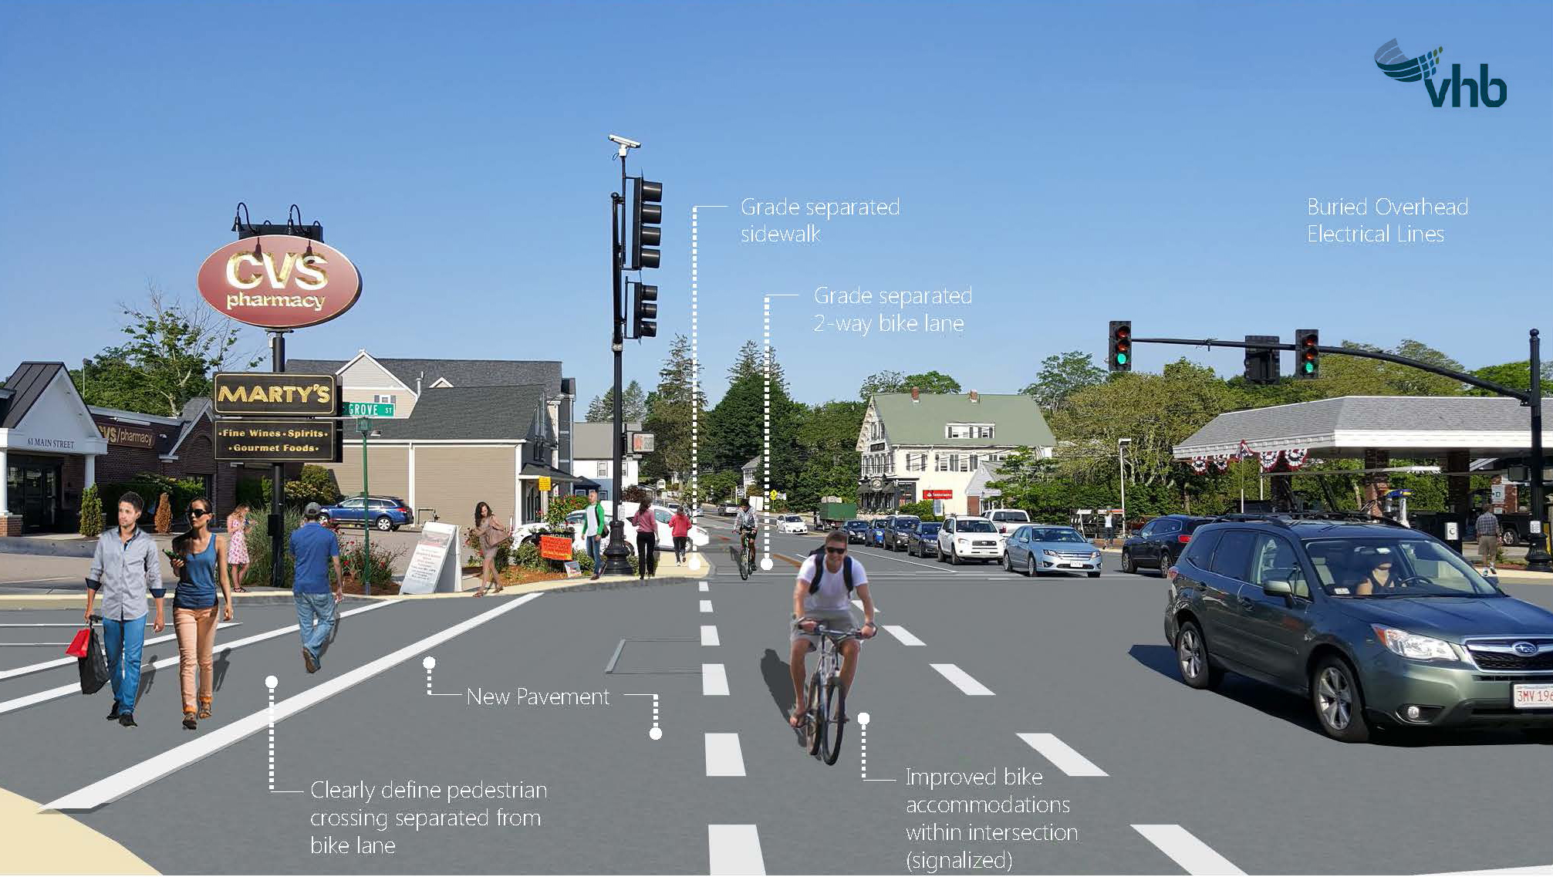

Project Concerns
This project will not improve traffic in downtown Hopkinton.

Project Fact:

● Realigned 85/135 Intersection to almost 100 percent straight

● Queue lengths and delay will improve at intersection .

● Complete Accessibility Throughout Project Duration

● Separated Bike Lane

● New pavement

● Complete New Drainage System

● New Traffic Signals

● Significant Aesthetic Improvements: Undergrounding of Utilities,
Increased Green Space, Period Lighting, Streetscape
Improvement (benches, trash receptacles, bike racks)

● Improving The Safety And Efficiency Of The Corridor For All
Users (Pedestrians, Bicyclists, Motorists).

The design could have included additional lanes at the 85/135 intersection, but on-street parking spaces would have been lost. Because our businesses need parking, retaining as much on-street parking as possible was prioritized over level of service improvements that the additional lanes would have provided.

Main Street Corridor Project Fact Sheet Cont.

Project Concerns
Project is a waste of money. All the funds should go towards school projects.

Project Fact:
The latest construction cost for the Project is $15M+. The residents of Hopkinton are responsible for $3M. The $3M Town portion is for the undergrounding of utilities and other non-eligible items (ornamental lights, design, appraisal services, special treatments, etc).

Should the Town obtain additional grants the residents would be responsible for less than $3M. If the project is cancelled the funds will not be available for schools. School funding must be a separate town meeting article.

Project Concerns
Save money by just paving Main Street and fixing the sidewalks.

Project Fact:
The cost to simply mill and overlay Main Street (i.e. repave) and repair the sidewalks will likely cost the town more than $3M and would not correct drainage issues, improve pedestrian safety, or include landscaping or aesthetic enhancements. An estimate is currently being developed for an estimated cost of such a project. It was not completed at the time this update was being prepared. The intersection would not be straightened.

Project Concerns/Questions
Town Common is being reduced by up to 7,000 sf.

Project Fact:
There is NO LOSS of any Town Common space.

Main Street Corridor Project Fact Sheet Cont.

Project Concerns
Bike Lanes should not be part of the Project

Project Fact:
Bike accommodations are required to be included in the Project or the ($8M+) State/Federal Funding will not be available. In addition, taking bicycles out of the stream of car & truck traffic and putting them in a separated lane improves safety for both bicycles and vehicles. The separated two-way bike lane provides an important extension of the Center Trail through the downtown and then toward Hopkinton State Park and Ashland. It is part of the regional Upper Charles Trail, which will connect Sherborn, Holliston, Milford, Hopkinton, Ashland and Framingham. Milford and Holliston have completed their portions.

Without this connection through the downtown, there will always be a gap between the Center Trail (future Upper Charles Trail) and the easterly portion of the Upper Charles Trail, which is preliminarily designed to extend out behind Center School, heading east.

Project Concerns
Town did not notify property owners included in the Warrant for the May 2018 Annual Town Meeting under Article 47.

Project Fact:
The 2018 Annual Town Meeting warrant was posted as required by local and state law and was available online in advance of Town Meeting. Proposed Annual Town Meeting motions were also available in advance of Town Meeting. The warrant included the article in question (#47) along with all the parcel numbers.

Additionally, most of the property owners included in the project area were sent letters in November 2012 notifying them that temporary and/or permanent easements were being proposed on the property.

Main Street Corridor Project Fact Sheet Cont.

Project Concerns
Town is taking property with easements.

Project Fact:
An easement is access. Property is not being “taken” with temporary or permanent easements. Temporary easements will only be used by the contractor while work is being completed in front of that property. Temporary easements go away when the project is done. Permanent right of way easements are required if the proposed project impedes onto private property and will require permanent public access after the Project is completed. The property under the permanent easement is still private property, the property is not being taken. Property owners will be compensated for every easement granted.

There are approximately 87 temporary easements and 57 permanent easements. All easements will be professionally appraised and the owners compensated at market value. Moving the utility poles behind the sidewalk prompted the need for the majority of the permanent easements. The permanent easements in these cases are for the wires overhead. The remainder are in relation to 4 Main Street businesses in the downtown across from Town Hall.

Project Concerns
Access to driveways and businesses will be blocked.

Project Fact:
Access will be maintained. There may be occasional delays as with any roadway construction project.

Click here to see Downtown Corridor Layouts and more

Main Street Corridor Project Fact Sheet Cont.

Project Concerns
On street parking is being lost.

Project Fact:
Overall, the project is increasing the number of spaces and all spaces will meet current design and safety standards.

Some on street parking in certain areas is regrettably being lost (in front of Muffin House). All effort is being made to provide new parking in close vicinity to these areas (in this case new parking on Main Street in front of Hopkinton Drug). In 2019, annual Town Meeting voted to develop a public parking lot on property adjacent to the Muffin House and purchased another property on Walcott Street to develop Town Hall parking.

Project Concerns
Some of the existing stone walls will be lost.

Project Fact:
No stone walls will be lost. Some existing walls would be moved in accordance with special historic preservation specifications. Stone wall relocation within the Historic District has been approved by the Historic District Commission.

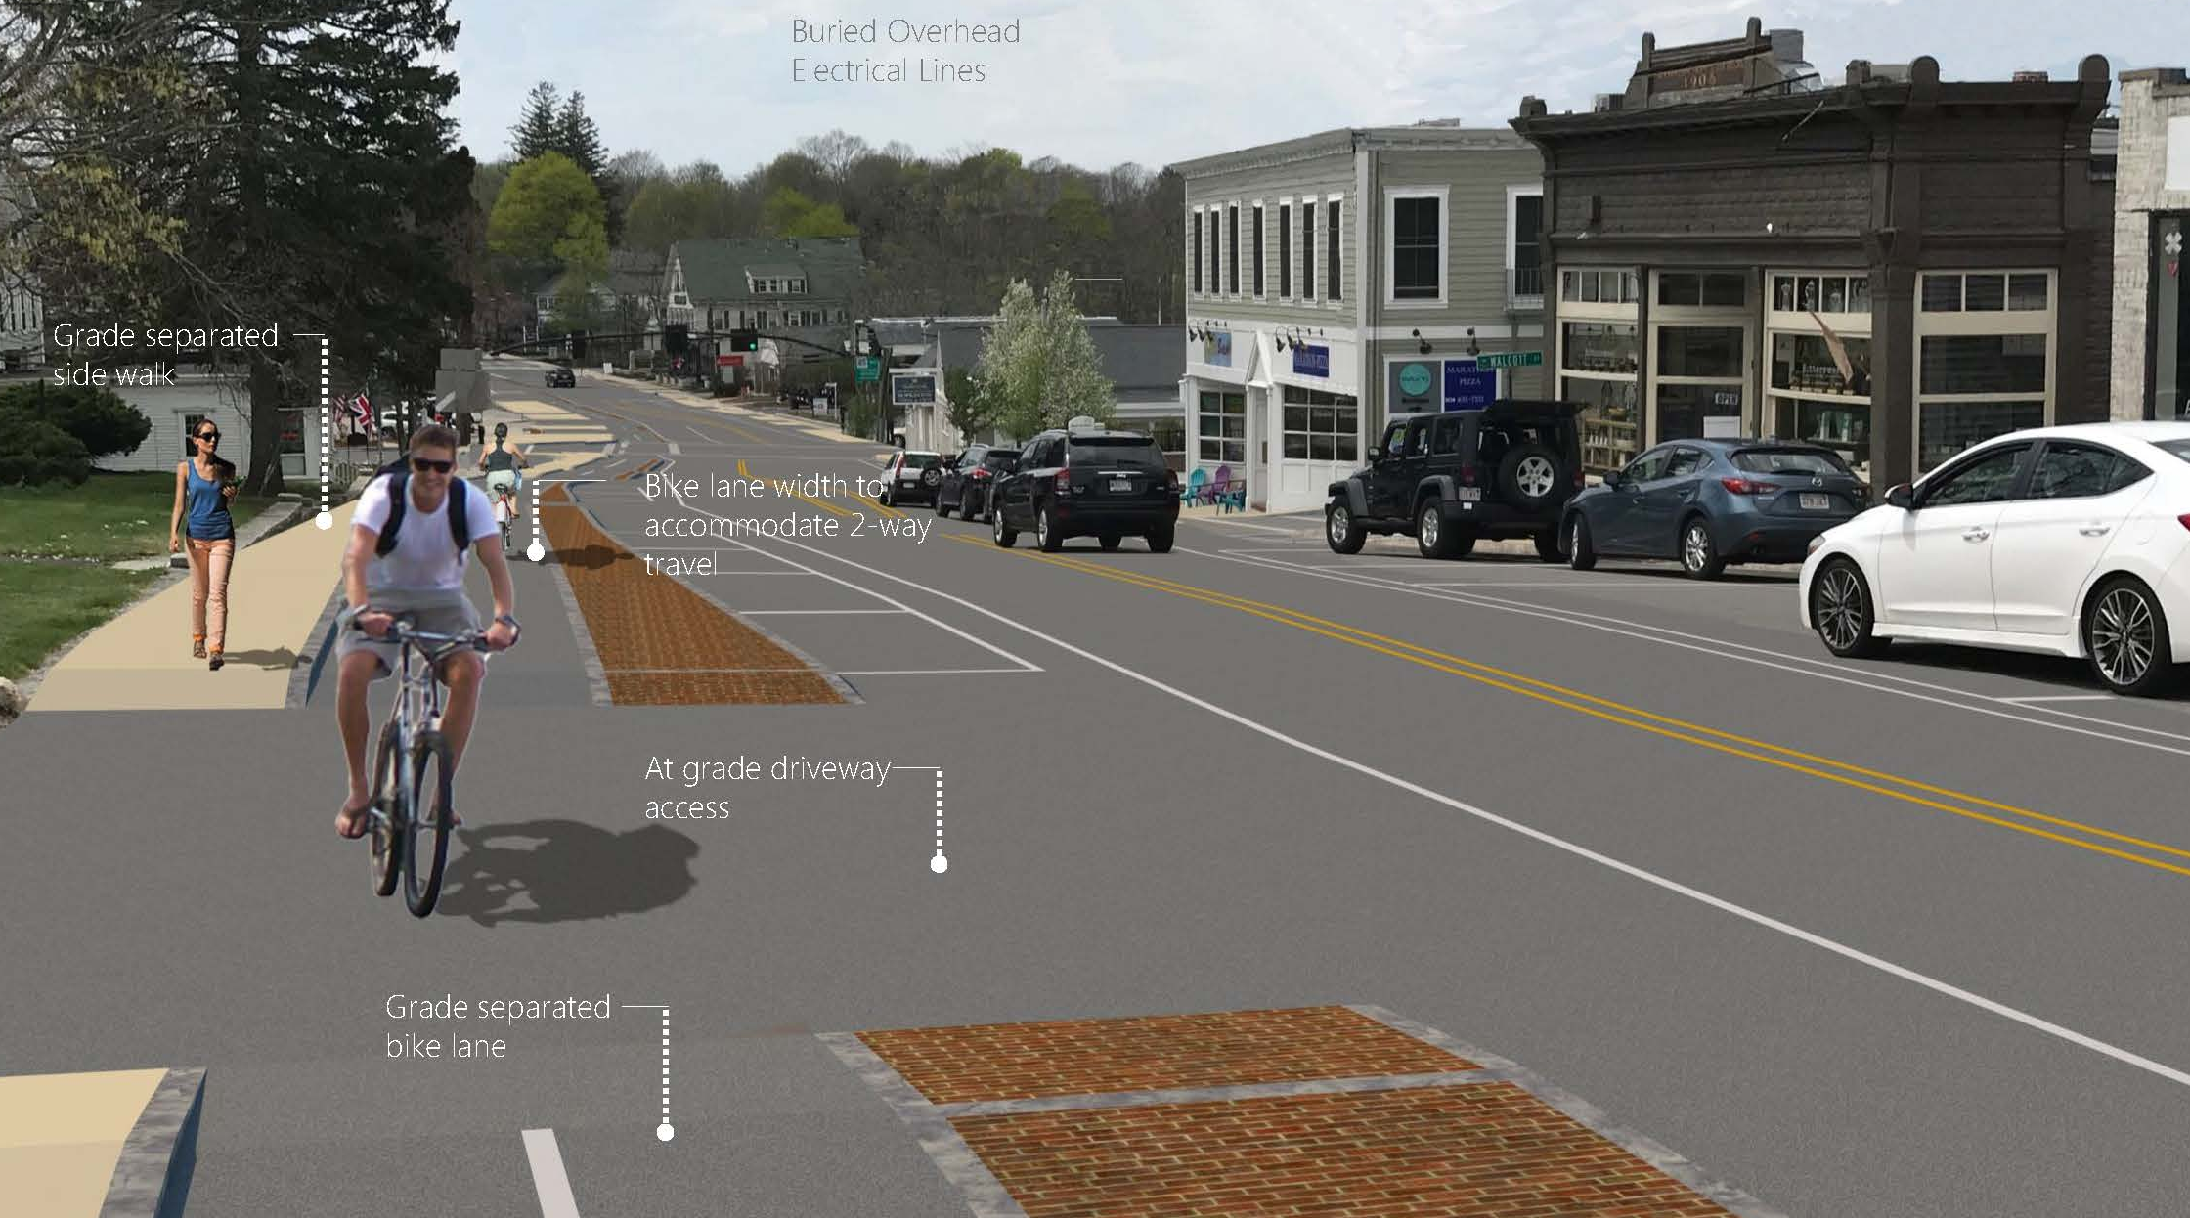

Main Street Corridor Project Fact Sheet Cont.

Project Concerns
Two-way bike lanes are unsafe and uncommon.

Project Fact:
Two-way bike lanes along roadways are indeed uncommon in the United States, but they do exist - and they are a fairly new concept. This two-way bike lane is an extension of the two-way Center Trail, and will become part of the two-way Upper Charles Trail. People who use bike paths are used to two-way bicycle traffic - the only difference here is that the two-way bike path is along the road.

The two-way bike path would be separated from the roadway by elevation (it is higher up than the road) and by a vertical curb. It is not anticipated that a two-way bike lane here would be any more unsafe than the two-way Upper Charles Trail in Milford, for example. Bike lanes are a requirement to receive State and Federal funding ($8M+) for this project.

Click here to see Downtown Corridor Layouts and more

Main Street Corridor Project Fact Sheet

Prepared by Hopkinton Select Board November 5, 2019

